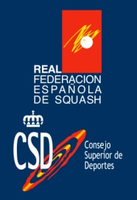


25th-27th of May 2018 in Santiago, A Coruña, Spain
ESF Junior Circuit – Junior Open event
PSA Junior Closed Satellite – WSF World Ranking

DATE
Friday May 25th 2018 – Sunday May 27th 2018 in Squash Santiago, Milladoiro, Ames, Spain.
The tournament is expected to start on Friday 26th 2017 at 10:00am. Prize ceremony is expected on Sunday 28th at 13.00 hrs.
Depending on the number of entries, we reserve the right to start the tournament before Friday at 10:00am.

CLOSING DATE
Thursday, May 11th 2018

CATEGORIES
Spanish Junior Open 2017 is open to players of any nationality under the age of 19, 17, 15 and 13 on the final day of the event provided the player is not banned under the ESF Junior Circuit Guidelines section C.4.e, section E.4.a or section E.4.b.
There will be a maximum draw of 32 players per category. A player can enter only one category.

ENTRIES
Only entries made through and/or endorsed by the relevant national federation will be accepted.
To enter the tournament please use the official entry form and send it by e-mail it to:
Squash Club Santiago. C/ Rosalía de Castro 59, Bajo. 15895 Milladoiro, Ames, A Coruña, SPAIN
Phone: +34 981 53 00 12
E-mail: sjo@squashsantiago.com

E-mail subject: "SJO2018" and "(Your Federation)"

Players must have an active, paid-for SPIN (Squash Personal Identification Number) to participate – see www.worldsquash.org/spin

By entering this tournament the MNA confirms that they will make sure that all relevant people (including coaches, managers and players) are aware of the ESF Junior Circuit Guidelines and their requirements as well as the rules for this tournament.

TOURNAMENT DIRECTOR

Jesús Souto – Tlf: +34 606 43 75 11 Mail: jesus.souto@squashsantiago.com

TOURNAMENT REFEREE

Pablo Rodriguez – Tlf: +34 981 53 00 12 Mail: sjo@squashsantiago.com










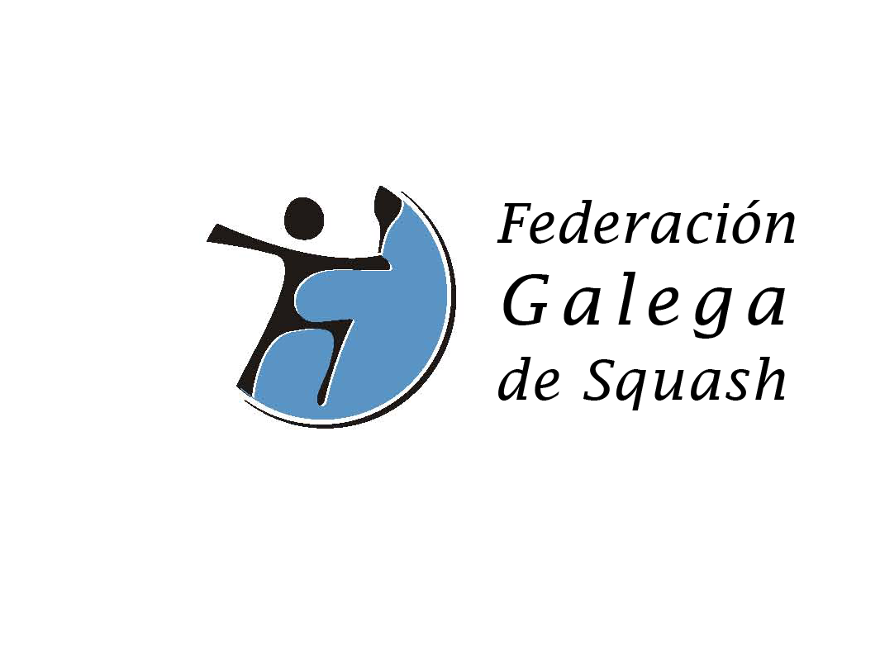

VENUE
Squash Club Santiago – C/ Rosalia de Castro 59 Bajo, 15895 Milladoiro – Ames – A Coruña – Spain
Phone: +34981530012 - 4 wall courts

HOTEL
- HOTEL PAYRO 2 *** ( to 400m Squash Santiago)
C/ Anxeriz, 12, 15895 Milladoiro, Ames (A Coruña) - Phone: +34 881 975 176
TRANSPORT
Transportation will be provided on arrival / departure to / from/ Santiago de Compostela Airport.
Participants will only be picked up if they notify the tournament organizers of their arrival times before Monday, 21th May.
There will be a shuttle transfer service between hotel and venue for all purchased a tournament package including hotel.

PACKAGE PRICES

A / Basic package 55€ per person
Entry fee + t-shirt + ESF levy.
B / Standard package 145€ per person
Entry fee + t-shirt + ESF levy + 2 nights bed and breakfast (accommodation in double rooms) + transport between airport/hotel/airport.
B1 / 195€ per person
Package B + 5 meals in the club.
C / 180€ per person
Entry fee + t-shirt + ESF levy + 3 nights bed and breakfast (accommodation in double rooms) + transport between airport/hotel/airport.
C1 / 230€ per person
Package C + 5 meals in the club.

Other packages consult the entry form.

Extra charge for single room 30€ per person per night.

Extra night double room 35€ per person per night.

Extra night single room 55€ per person per night.

Tournament package A: € 55,00 per person ONLY includes entry fee + Player pack (t-shirt…)=> No transport during the tournament.

ENTRY / PACKAGE FEE PER PERSON


Entries will only be recognized on reception of the entry form and the full Entry / Package Fee according to the entry form no later than the closing date.

The Package fee must be paid by bank transfer (net of bank charges) to:

PAYMENT DETAILS

Acc Holder: ASOCIACION DEPORTIVA SQUASH CLUB SANTIAGO
SWIFT BSABESBB
IBAN ES82 0081 0499 6900 0136 0246

Bank BANCO SABADELL
ADRESS C/ GENERAL PARDIÑAS 20
15701 SANTIAGO

Please mark payment clearly with: "SJO2017" and "(your federation)".
In case of withdrawal, fees will be reimbursed according to ESF Junior Circuit Guidelines, section E.
Entries will be acknowledged by players and coaches being listed on the www.squash.no , Entries list.

ESF and WSF ranking points
Categories under 13, 15, 17 and 19 will earn ranking points to the ESF junior ranking.
Category under 19 will also earn ranking points to the WSF junior ranking.

DRAWS AND SEEDINGS
The seeding and schedules will be published on:
http://www.squashsantiago.com/competicion
The seeding and draw will be carried out using the ESF Junior Rankings valid at the tournament closing date, in accordance with the ESF Junior Circuit Guidelines section D.

MATCHES
All matches will be played as best of five games with PAR 11 scoring to 2 clear points.
All players will be guaranteed a minimum of three scheduled matches.
All positions in the categories will be played out.
ESF approved balls will be used in all matches.
All players will be expected to mark and referee matches.
Wearing of approved eye protection on court is mandatory at all time. Players will not be allowed to compete without approved eye protection.

PRIZES
There will be trophies in all categories.

INSURANCE
Players enter and play in the tournament at their own risk. Neither the organizers nor the ESF or WSF accept any responsibility for injury arising from participating in the event. Players must arrange their own insurance.

PUBLISHING STATEMENT
The tournament organizers will publish draws, results, stories and photos of players at venue and hotel. As this is part of the tournament rules, the organizer will deem that players and their parents have accepted these regulations by entering the tournament.

EYEWEAR
It is mandatory to use eyewear in all categories.

ESF PENALTIES from ESF Junior Circuit Guidelines section E.

§E.4.a If a player makes a late withdrawal from a tournament (2 days or less before the start date), a doctor’s certificate confirming injury/illness must be provided to avoid penalties. The medical certificate (with a translation in English) must clearly state the player’s name, date of birth and the nature of the illness/injury; the certificate must cover the date of the relevant tournament and must be sent to the ESF office no later than two days after the final day of the tournament (email: esf@europeansquash.com; fax +44 1424 774879). Any player making a late withdrawal not supported by a medical certificate will receive zero points for the tournament which will count as one of their 4 best results for the rolling 12 month period and will be taken into account when dividing the points to obtain the ranking average. This penalty will be applied automatically unless the ESF office receives a doctor’s certificate within two days of the tournament finishing.
If a player commits this offence for a second time within a 12 month period, he/she will be banned from the ESF Junior Circuit for a period of 12 months.
§E.4.b If a player has entered a tournament and fails to turn up, he/she will receive zero ranking points for the tournament. These zero points will count as one of the player’s 4 best results for the rolling 12 month period and will be taken into account when dividing the points to obtain the ranking average. This penalty will be applied automatically.
If a player commits this offence for a second time within a 12 month period, he/she will be banned from the ESF Junior Circuit for a period of 12 months.
§E.4.c If a player fails to play out all scheduled matches for any reason other than illness or injury, he/she will receive zero ranking points for the tournament. Illness or injury must be verified by the tournament director and, if possible, by medical certificate sent to the ESF office within two days of the tournament finishing. If zero points are awarded, the points will count as one of the player’s 4 best results for the rolling 12 month period and will be taken into account when dividing the points to obtain the ranking average. This penalty will be applied automatically.

If a player commits this offence for a second time within a 12 month period, he/she will be banned from the ESF Junior Circuit for a period of 12 months.

