**Czech Squash Masters**

**European Masters | Grand Prix | Event**



**Contacts**

**Tournament director: Tournament referee:**

Ms. Sonja Brabcová Ms. Renata Nejtková

Maximus z.s.

gsm: +420 603 228 838 gsm: +420 725 839 991

e-mail: [sona.brabcova@mxms.cz](mailto:sona.brabcova@mxms.cz) e-mail: [re02ne@seznam.cz](mailto:re02ne@seznam.cz)

**The MSC responsible for this event:**

Mr. Jean-Marc Fraipont

Belgium

[jm.fraipont@mail.be](mailto:jm.fraipont@mail.be)

(or [jean-marc.fraipont@europeansquash.com](mailto:jean-marc.fraipont@europeansquash.com))

**Date, Event category**

This European Masters Grand Prix event will be held in **PRAGUE**, Czech Republic, from **April 20st to April 22nd 2018**. The tournament will start on April 20st at 9:00. The Prize Giving Ceremony takes place at the latest at 15:00 on April 22nd.

**Closing date for entries**

**30.3.2018**

Late entries are only acceptable before the seeding is published at the discretion of the Tournament Director and Masters Sub-Committee in the interest of the tournament.

**Venues**

SBCentrum

K Horkám 2284/1

Prague 4, 149 00

Tel: +420 272 924 492

[www.sbcentrum.cz](http://www.sbcentrum.cz)

6 Fiberesin courts

Squasharena

Cholupická 431

Prague 4, 142 00

Tel.: +420 241 470 928

[www.squasharena.cz](http://www.squasharena.cz)

5 Fiberesin courts

**Categories**

Men: 35+, 40+, 45+, 50+, 55+, 60+, 65+, 70+, 75+

Women: 35+, 40+, 45+, 50+, 55+, 60+, 65+, 70+, 75+

The TD reserves the right to amalgamate age groups if there are insufficient entries to make a workable draw. Players are only allowed to enter one category.

**Eligibility**

This event is open to all players who are over 35, 40, 45, 50, 55, 60, 65, 70, 75 on the first day of the event. As specified by the WSF and ESF, to compete in all ESF Registered events players must hold an active Squash Player Identification Number (SPIN), which is approved and validated by his MNA. Objections after the closing date will not be accepted. Players without a SPIN can register through the WSF website [www.worldsquash.org/spin](http://www.worldsquash.org/spin)

**Seeding**

The seeding will be carried out by the Masters Sub-Committee Seeding Panel using the latest available results and ESF Masters Rankings valid at the closing date and in accordance with the ESF Masters Circuit Guidelines.

**Matches**

All matches played will consist of the best of five games, under the rules of the WSF. All players are guaranteed a minimum of three matches. The Tournament Organizers’ will organize plate matches consisting of the best of five games. PAR 11 scoring (to 2 clear points) will be used.

**Draws**

Maximum draw size: 64 (3 day event).

**Refereeing**

Both players will be expected to mark and referee matches, usually the next match on the court, where they played. Scoreboards will be available at every court.

**Ball**

DUNLOP PRO XX.

**Prizes**

The Prize Giving Ceremony takes place at the latest at 15:00 on Sunday April 22nd. Trophies for 1st, 2nd and 3rd place.

**Insurance**

Players enter and play in the tournament at their own risk. Neither the organizers’ nor the ESF will accept responsibility for any claims including for injury or accident. Suitable insurance must be organized by the player or the participating federation.

**Hotel**

**IRIS HOTEL EDEN **** (official hotel)**  
Vladivostocká 1540/2, 100 00 Praha 10, www.irishoteleden.cz

* 6,6 km from SBCentrum, 7,8 km from SquashArena

Reservations can be made only by the tournament organizers.

**Transport**

Players who book packages “C”, “C1”, “D” and “D1” will be picked-up and dropped off at PRG Airport. On all playing days there will be a regular bus transfer service between the official hotel and the venues.

**Entries**

The European Masters Circuit is open to all Masters of any nationality provided the player is not banned by his MNA. All entries must be on the official entry form and sent to: Maximus z.s. [sona.brabcova@mxms.cz](mailto:sona.brabcova@mxms.cz) or heiko_schwarzer@web.de

**Payment**

The fees and packages, as detailed below, along with the ranking levy of €4 per player must be paid to the host prior the closing date.

Beneficiary Bank: FIO banka, a.s.

Millenium Plaza

V Celnici 10

117 21 Praha 1

Clearing Nr. **2010**

Account Nr: **2400511108**

Account name: Max – Eur

Account holder: Maximus

Acc. Holder address: Spojovaci 210

252 45 Dolni Brezany Czech Republic

SWIFT Code/BIC: FIOBCZPPXXX

IBAN: CZ4720100000002400511108

**Please mark payment clearly with name of event and name of player. Please pay ALL fees. Organiser has to get the FULL amount.**

**Hotel & Food packages:**

1. 60,- € Entry fee together with the ESF Levy and tournament t-shirt
2. 100,- € Entry fee + 5 meals (Friday 2x, Saturday 2x, Sunday 1x)
3. 265,- € per person, accommodation in DOUBLE ROOM (2 nights) + Entry fee + 5 meals +

shuttle + 2x breakfast + Saturday party

C1) 325,- € per person, accommodation in SINGLE ROOM (2 nights) + Entry fee + 5 meals +

shuttle + 2x breakfast + Saturday party

1. 305,- € per person, accommodation in DOUBLE ROOM (3 nights) + Entry fee + 5 meals +

shuttle + 3x breakfast + Saturday party

D1) 395,- € per person, accommodation in SINGLE ROOM (3 nights) + Entry fee + 5 meals +

shuttle + 3x breakfast + Saturday party

1. 40,- € Extra night/double room

E1) 70,- € Extra night/single room

F) 25,- € Saturday Party

G) 30,- € Friday BOAT trip on Vltava river with guide (ENG, DEU), buffet and aperitif.

H) *Accompanying person – packages C, C1, D, D1 minus package A.*

Please use for this information the NOTE field.

**Draws**

The seeding lists and time of the first matches for specific age groups will be published 7 days prior to the start date on the ESF Website

Finalized draws for the event will be published on the ESF Website at about 17:00 on the day before the tournament.

Up-to-Date information about this and all other ESF Masters Tournaments will be published regularly in the Facebook group “European Squash Masters”. Please join up today!

**ESF regulations & penalties**

This event complies with the ESF Masters Circuit Guidelines, a copy of which is available on the ESF website.

A late withdrawal is a withdrawal made 2 days or less before the start date of a tournament. Ranking penalties may be applied to the records of players who fail to turn up or who make a late withdrawal not supported by a medical certificate.

Following a withdrawal, fees and packages should be reimbursed as follows:

1. Withdrawal up to 31 days before the start date of a tournament: fees reimbursed in full (less bank charges).
2. Withdrawal 7-30 days before the start date of a tournament: 50% of fees reimbursed (less bank charges).
3. Withdrawal 6 days or less before the start date of a tournament: reimbursement at the discretion of the tournament organizer

If a player:

a) Has entered a tournament and fails to turn up, he/she may receive zero ranking points for the tournament

b) Fails to play out all scheduled matches for any reason other than illness or injury, he/she may receive zero ranking points for the tournament

1. Commits either of these offence for a second time within a 12 month period, he/she may be banned from the ESF Masters Circuit for a period of 12 months

**We are looking forward to welcome you in Prague.**

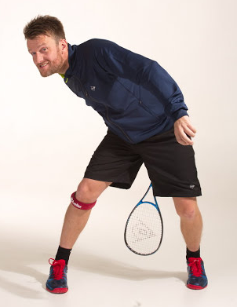

**Renata & Soňa & Denisa & Heiko**

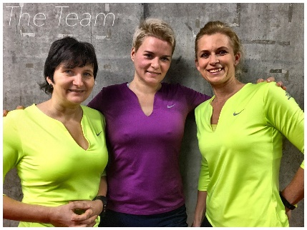

**The Team ☺**