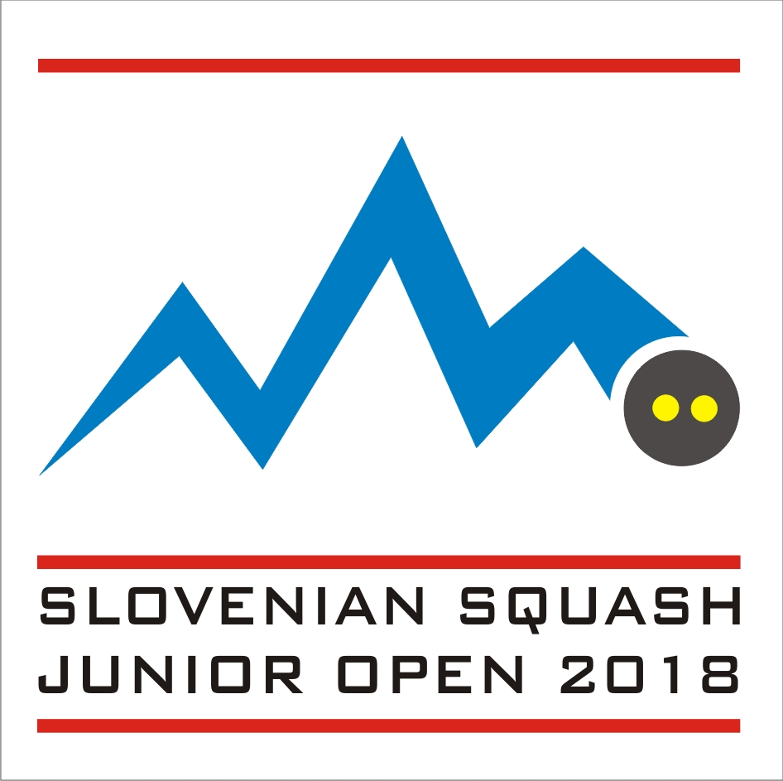
Invitation and application form for
Slovenian Junior Open 2018

All informations regarding Slovenian Junior Open can be found on sjo.squash.si

Date:
Friday 2nd – 4th February 2018
The tournament begins on Friday (2.2.) at 14:00 at the Konex Center

Closing date for entries: 15th December 2017

Venue:
Konex Sports Centre
Cesta na Brdo 109
1000 Ljubljana
+386 1 241 40 00 (phone)
info@konex-center.si
www.konex-center.si

4 Squash Courts, Badminton, Fitness, Bar.

Categories:
Boys and Girls under 13, 15, 17 and 19 years.
Players are allowed to enter one category only.

Eligibility:
The Slovenian Junior Open is open to all players under the age of 13, 15, 17 and 19 on the 4th February 2018 (final scheduled date of the event). Players and coaches cannot participate without an active SPIN (Squash Personal Identification Number) – please visit www.worldsquash.org/spin to register

Seeding:
The seeding will be carried out using the European Junior Ranking valid at the closing date. Players without an ESF Junior Ranking will be seeded by the Tournament Director.

Matches:
All matches will be played best of five games, under the rules of the WSF. All players are guaranteed a minimum of three matches. The Tournament Organisers reserve the right to organize plate matches consisting, played to best of three games.

PAR 11 scoring will be used.

Draws:
Maximum draw size Boys U13-19: 32 players
Maximum draw size Girls U13-19: 32 players
Refereeing:
All players will be expected to mark and referee matches.

Ball:
DUNLOP PRO XX.

Prizes:
There will be gift prizes and medals in all categories.

Insurance:
Players enter and play at the tournament on their own risk. Neither the organisers nor the ESF will accept any responsibility for claims including for injury or accident.
Suitable insurance must be organised by the player or the participating federation. All players have to wear approved protective eye guards on court.

Hotel:
M hotel
Derčeva ulica 4, SI-1000 Ljubljana
https://www.m-hotel.si/
Reservations can only be made by the tournament organisers.

Transport:
Players and officials will be picked-up and dropped off at Ljubljana Airport (Jože Pučnik - LJU) and Ljubljana Central Station. Pickup and nearby airports are organised upon request.

Entries:
All entries must be made through / endorsed by a player’s national association. Any entry not approved by the player’s national association will not be accepted.

All entries must be made on the official entry form and sent by e-mail to:

Slovenian Squash Association zveza@squash.si
Cesta na Brdo 109 GSM: +386 41 362 329
SI-1000 Ljubljana (Slovenia)

Web Publishing:
Organisers withhold the right to publish pictures and videos of all participants, taken during the event. As this is a part of the Slovenian Junior Open tournament regulations, the Slovenian Squash Association will deem that players and their parents have accepted these regulations by entering the tournament.

Entry fees:

Tournament package 1: € 260 per person, including entry fee + 4 nights bed and breakfast accommodation in double/triple rooms, 6 meals, transportation between hotel and venue + T-shirt.

Tournament package 2: € 220 per person, including entry fee + 3 nights bed and breakfast accommodation in double/triple rooms, 6 meals, transportation between hotel and venue + T-shirt.

Tournament package 3: € 160 per person, including entry fee + 2 nights bed and breakfast accommodation in double/triple rooms, 4 meals, transportation between hotel and venue + T-shirt.

Tournament package 4: € 52 per person, Entry Fee (+T-Shirt)

The entry and package fees must be paid by bank transfer (net of bank charges, latest by closing date!) to:

Beneficiary Bank: Delavska hranilnica d.d.
Bank Address: Miklošičeva 5, 1000 Ljubljana
Account Name: Squash zveza Slovenije
IBAN: SI56 6100 0000 5613 640
SWIFT Code/BIC: HDELSI22

Please mark payment clearly SLOVENIAN JUNIOR OPEN 2018 + SURNAME AND NAME OF A PLAYER .

Cancellations:
For cancellations for at least 21 days before event, 33% of the package fee (less bank charges) is charged as cancellation fee. For cancellations between 20 and 15 days before event, 50% and 80% for between 15 and 7 days. Later cancellations are not refoundable.

Draws:
The seeding will be circulated to all players or their national associations by e-mail at least 7 days before the start of the event. Times of first matches will be indicated for their respective players.

Eye guards:
Wearing of approved eye protection on court is mandatory for this event. Players will not be allowed to compete without approved eye protection. Check WSF website for more details.

ESF regulations & penalties
This tournament is part of the ESF Junior Circuit and will be run in accordance with the ESF Junior Circuit Guidelines, a copy of which is available on the ESF website www.europeansquash.com. All participating MNAs should make sure that all relevant people (including coaches, managers and players) are aware of the Guidelines and their requirements.

E. 4.a) If a player makes a late withdrawal from a tournament (two days or less before the start date), a doctor’s certificate confirming injury/illness must be provided to avoid penalties. The medical certificate (with a translation in English) must clearly state the player’s name, date of birth and the nature of the illness/injury; the certificate must cover the date of the relevant tournament and must be sent to the ESF office within two days after the final day of the tournament (email: esf@europeansquash.com; fax +44 1424 774879). Any player making a late withdrawal not supported by a medical certificate will receive zero points for the tournament which will count as one of their 4 best results for the rolling 12 month period and will be taken into account when dividing the points to obtain the ranking average. This penalty will be applied automatically unless the ESF office receives a doctor’s certificate within two days of the final day of the tournament.
If a player commits this offence for a second time within a 12 month period, he/she will be banned from the ESF Junior Circuit for a period of 12 months.

b) If a player has entered a tournament and fails to turn up, he/she will receive zero ranking points for the tournament. These zero points will count as one of the player’s 4 best results for the rolling 12 month period and will be taken into account when dividing the points to obtain the ranking average. This penalty will be applied automatically.
If a player commits this offence for a second time within a 12 month period, he/she will be banned from the ESF Junior Circuit for a period of 12 months.

c) If a player fails to play out all scheduled matches for any reason other than illness or injury, he/she will receive zero ranking points for the tournament. Illness or injury must be verified by the tournament director and, if possible, by medical certificate sent to the ESF office within two days of the final day of the tournament. If zero points are awarded, the points will count as one of the player’s 4 best results for the rolling 12 month period and will be taken into account when dividing the points to obtain the ranking average. This penalty will be applied automatically.

If a player commits this offence for a second time within a 12 month period, he/she will be banned from the ESF Junior Circuit for a period of 12 months.

Closing date:

Friday 15th December, 2017

ENTRY FORM for Slovenian Junior Open 2018

National Association

Phone e-mail

Coach / Responsible Person

Name

Address

Phone e-mail

PACKAGES

Name | Date of Birth | SPIN | T shirt size | Event | National  Ranking | Tournament  Package | Extra night from …to | single  room

Please return this form by 15th DECEMBER, 2017:
Slovenian Squash Association zveza@squash.si
Cesta na Brdo 109 +386 41 362 329 (phone)
SI-1000 Ljubljana (Slovenia)
Arrival & departure details
Slovenian Junior Open 2018

National Association

Phone Fax

e-mail

Please fill out:

O we arrange our own transport.
O we require transportation according to the list below.

Travel details:

Name | Arrival  date | Arrival  Time | Flight # | Dep.  date | Dep  Time | Flight #

Please return this form by 15th DECEMBER, 2017:

Slovenian Squash Association zveza@squash.si
Cesta na Brdo 109 +386 41 362 329 (phone)
SI-1000 Ljubljana (Slovenia)

